**Use Google and Whois for Reconnaisasance**

**Aim:** To find out the Whois, DNS Records and Diagonstics for particular website by using Whois search.

**Procedure:**

Step1: Open the WHO.is website

Step 2: Enter the website name in search bar and hit the “Enter button”.

Step 3: Show you information about [www.saveetha.com](http://www.saveetha.com/)

**Output:**

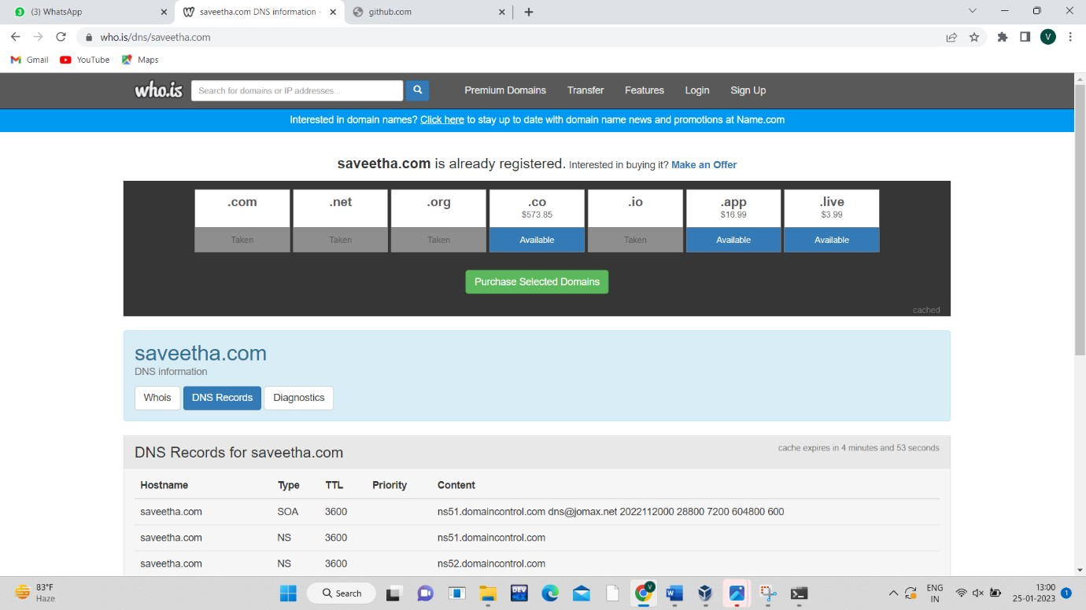

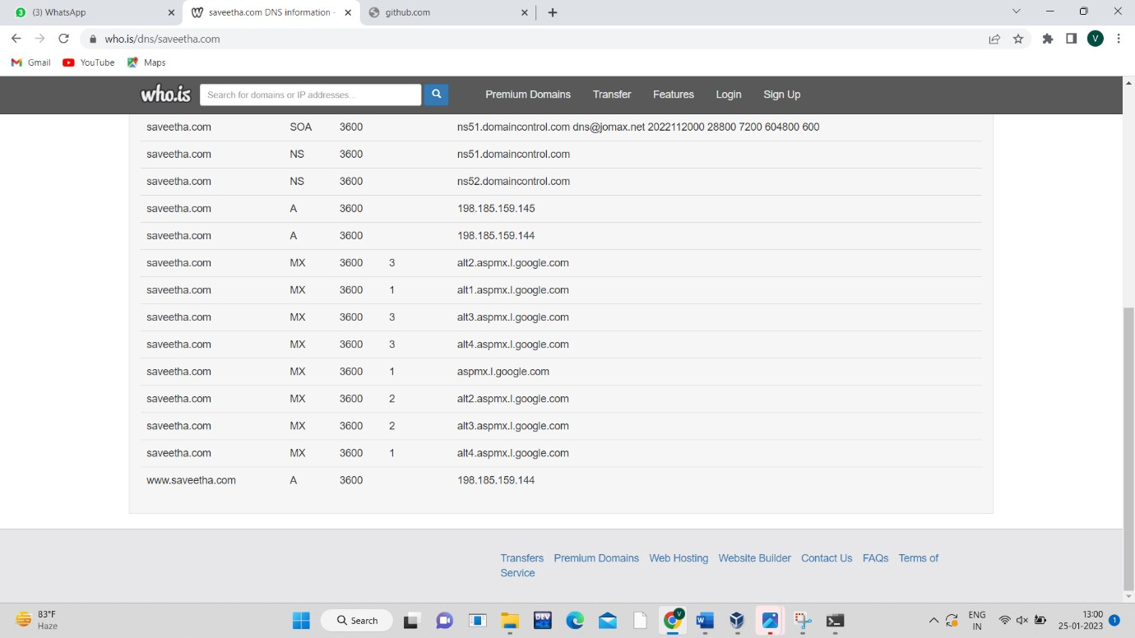

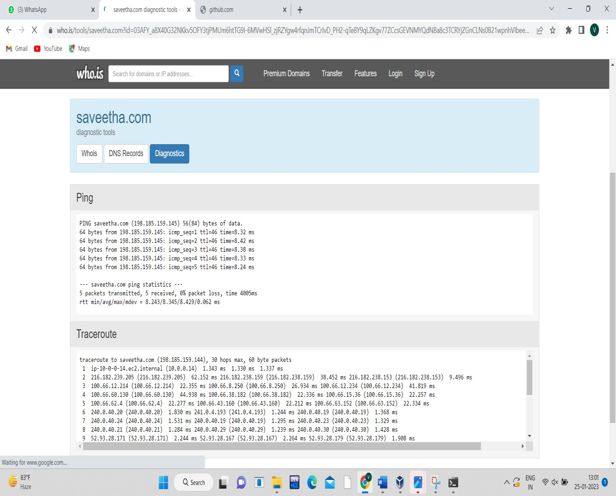

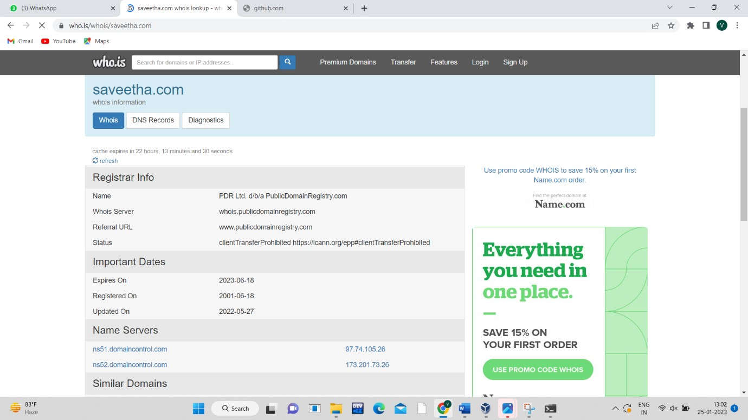

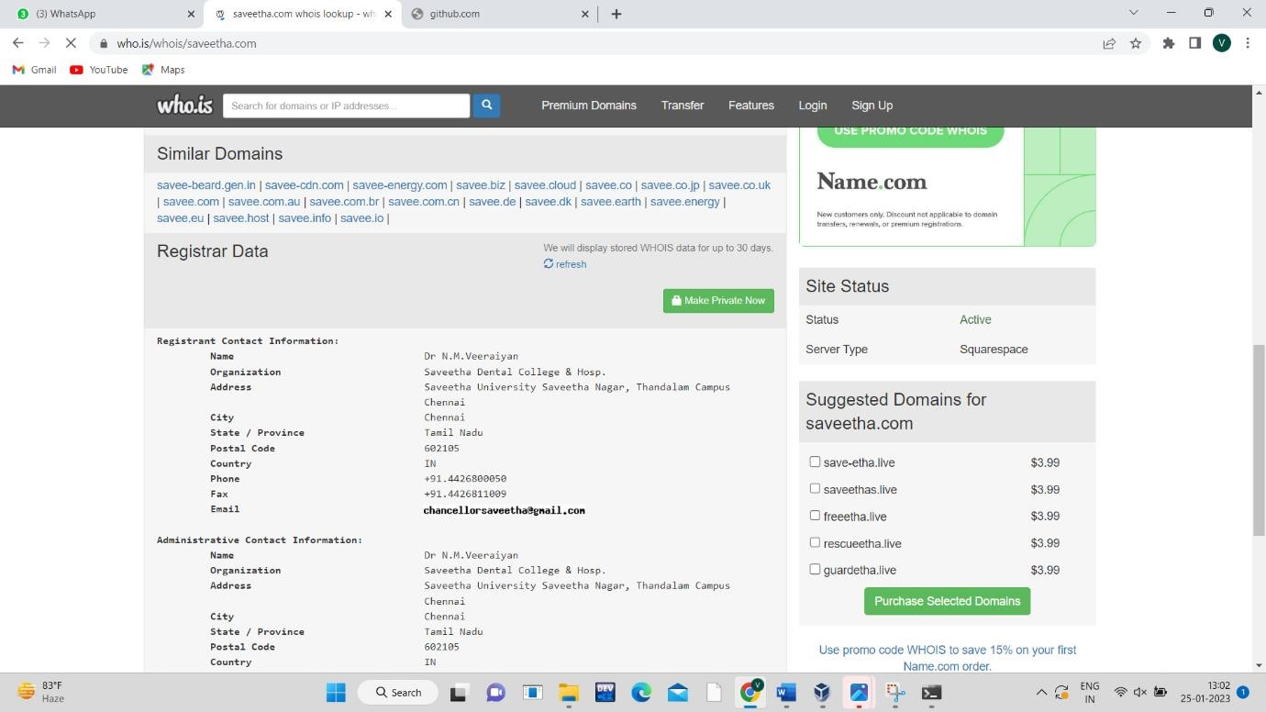

**Result:**

Hence the DNS records and diagonstics for particular website by using Whois search

has found out successfully.